Automated Reasoning — Fundamentals & Why It Matters
Automated reasoning is the field of computer science and logic that builds systems to “think” by making logical inferences. It starts from basic logic: if you know premises are true (e.g. “All men are mortal”, “Socrates is a man”), you can deduce that a conclusion is true (e.g. “Socrates is mortal”). In computer terms, reasoning means deriving new facts or proofs from a set of known facts (the knowledge base or axioms) using formal inference rules[1]. Historically, this goes back to Aristotle’s syllogisms (formalising “All A are B, all B are C, therefore all A are C”), evolved through Frege’s predicate logic (Begriffsschrift, 1879) and the foundations of computability (Turing, Church in the 1930s) and culminated in Robison’s resolution principle (1965) and modern SAT/SMT solvers. Today’s automated reasoning systems encode knowledge (often as logical formulas or constraints) and apply search and inference to prove theorems or find counterexamples[1].
Automated reasoning relies on three pillars: Representation, Inference, and Search. Representation means encoding domain knowledge in a formal language (propositional logic, first-order logic, type theories, etc.). Inference means applying logical rules (like modus ponens or resolution) to derive new conclusions. Search means exploring the huge space of possible inferences or proofs efficiently (using backtracking, heuristics, SAT/SMT solving, model checking, etc.). For example, a proof search might backtrack like an appeals court reconsidering an argument, trying alternate lines of reasoning until a valid proof (or a counterexample) is found.
Different reasoning modes have different guarantees. Deductive reasoning is sound: if the premises are true, the conclusion must be true. For example, from “All birds can fly” and “A penguin is a bird”, you deduce “A penguin can fly” (which is false in reality because the premise was wrong). In logic, soundness means “anything proved is true”[2]. Inductive reasoning generalises from examples: seeing many black swans and concluding “All swans are black” is an inductive inference – likely but not guaranteed. Abductive reasoning is inference to the best explanation: given observations, you guess the simplest cause (e.g. Mary is wet, so you abductively infer “It must have rained”), but the conclusion is not certain. In logic literature, abduction means finding a plausible hypothesis consistent with the data[3]. Deduction has logical guarantees, whereas induction and abduction yield plausible but uncertain conclusions.
A helpful analogy is navigation. Think of the knowledge base as a map: it encodes what is known (like roads and cities). The goal theorem is the destination. Proof search is like route planning – you explore paths of reasoning (roads) from your premises (current location) to reach the theorem (destination). Heuristics (e.g. which inference rule to try) are like live traffic data guiding your route choice. If a path fails or leads to a dead end, you backtrack (like rerouting). In this analogy, an automated theorem prover is like a GPS: it systematically navigates the map of knowledge to prove a claim.
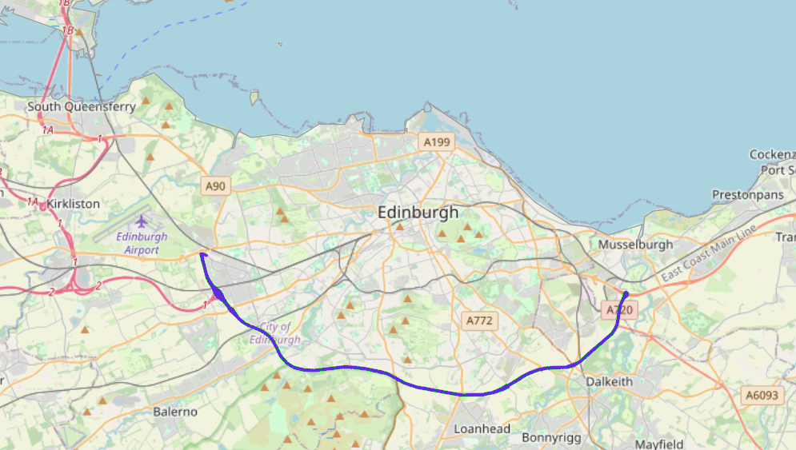
Figure: A map (knowledge base) and planned route (proof) from Edinburgh Airport to Bonnyrigg. In automated reasoning, the “map” is logical knowledge, and searching for a proof is like planning a route. Heuristics (e.g. SAT solver heuristics) guide the search path as traffic data would guide route choice.
Another analogy is the legal system. Laws and rules of the system are like axioms; evidence or case facts are like premises. A lawyer (inference engine) builds logical arguments (proofs) from laws and evidence. A judge (verification system) checks if the argument is valid (sound). If an argument fails, you appeal (backtracking) and try an alternative strategy. This analogy highlights that automated reasoning constructs and checks arguments much like lawyers do with laws and facts.
Why does this matter, and why not just use neural networks (like LLMs) for all reasoning? Modern LLMs are powerful at pattern recognition and generating plausible text, but they often fail on precise reasoning tasks. For example, LLMs make arithmetic mistakes (e.g. miscounting objects or wrong sums)[4], produce logically inconsistent answers (generating contradictory statements within the same argument)[5], and even “hallucinate” fake proofs or facts when pressed. They lack guarantees: since each token is chosen by probability, not logical validity, any multi-step chain can go awry. Concrete failure cases include math word problems solved incorrectly, or GPT hallucinating a reference that doesn’t exist. In contrast, automated reasoning provides correctness guarantees.
In safety-critical domains (aerospace, medical devices, finance, nuclear systems, etc.) we cannot tolerate uncertainty or bugs. The cost of an error can be catastrophic: millions lost or lives endangered. For instance, Boeing’s 787 software is so critical that many insist on formal verification of its flight control code (ensuring soundness and completeness of logic)[2]. Soundness means “if the proof system proves something, it is guaranteed true”, and completeness means “if something is true (in the system), the system can eventually prove it”[2]. These properties assure that there are no hidden flaws. A neural system is like a brilliant but unreliable intern: it might propose an answer, but without formal proof. Automated reasoning is like a meticulous auditor: it checks every step. The history of engineering disasters underscores this: the Ariane 5 rocket (over €370M loss) crashed due to an unchecked integer overflow in reused code[6]; the Intel Pentium FDIV bug (1994) caused a \$475M recall[7]; the Knight Capital trading glitch lost \$440M in minutes[8]; Boeing 737 MAX’s flawed MCAS logic contributed to fatal crashes; the Therac-25 radiation machine killed patients through a software race-condition bug[9]. In each case, a formal check or model analysis would likely have caught the error early.
Ten real-world use cases show how automated reasoning is applied today:
- Hardware verification: Modern CPUs and chips are verified using model checking or equivalence checking. For example, after the Pentium FDIV error (1994), Intel and others began using theorem provers on hardware designs. SAT/SMT solvers and BDDs check that a redesigned circuit matches the spec. This prevents critical arithmetic or logic bugs[7].
- Software verification: Companies use formal methods to find bugs. Amazon Web Services, for instance, had its TLS library s2n formally verified: Galois Inc. proved the HMAC and RNG code correct with a proof assistant (SAW/Cryptol)[10]. AWS also built Zelkova, an SMT-based policy checker to verify IAM/S3 policies, catching misconfigurations automatically[11]. Microsoft applied model checking to Hyper-V (the Windows hypervisor), preventing several critical security bugs. These tools prove properties of code before release.
- Medical diagnosis and clinical decision support: In medicine, ontologies (e.g. SNOMED CT) formalize symptoms, diseases and treatments. Ontology-based systems encode medical knowledge and use logical inference to check patient data against rules. For instance, a system might encode “If symptom X and symptom Y, suggest disease Z” in a logic ontology[12]. A patient’s data are facts, and inference engines deduce possible diagnoses. Unlike a pure neural image classifier, this approach yields an explainable reasoning chain (why a diagnosis was suggested).
- Autonomous vehicle planning: Self-driving cars must respect safety constraints (e.g. “always stop at red”, “keep safe distance”). These can be expressed in temporal logic (e.g. LTL). Planners and controllers are then verified or synthesized against these constraints using model checking or SMT solvers. For example, a planner might ensure “the vehicle never enters an intersection during a red light signal”. Formal verification of the planning logic (or synthesis of safe trajectories) can prove these properties hold in all scenarios. This helps avoid tragic accidents from unhandled corner cases.
- Compiler verification / proof-carrying code: Compilers translate code and optimizations must preserve meaning. Proof-carrying code and verified compilers (like CompCert) embed formal proofs that compiled code respects the source semantics. The CompCert C compiler (INRIA, 2006) is a standout: written and proved correct in Coq, it ensures that compiled binaries faithfully implement the C source[13]. This prevents miscompilation bugs. Similarly, proof-carrying code techniques let untrusted code come with a proof of safety verified by the OS/kernel before execution.
- Cybersecurity: Security protocols and network configurations can be model-checked for flaws. Tools like SPIN or ProVerif analyze cryptographic protocols (e.g. TLS handshakes, OSPF routing) to find vulnerabilities. For instance, model checking the TLS 1.3 handshake or using Murphi to verify cache coherence can uncover subtle logic bugs. Automated reasoning ensures that no sequence of actions leads to a breach.
- Financial compliance and rule engines: Financial systems must follow complex regulations. Rule engines encode regulations (anti-money laundering checks, trading limits, tax rules) as logical conditions. Automated reasoning tools (often SAT/SMT under the hood) then check transactions or reports against these rules. AWS reports that financial services use formal logic to encode compliance in their “Guardrails” service[14]. For example, a compliance rule “If trade >$10M and counterparty rating <C, raise alert” can be checked exhaustively on all transactions. This catches illegal trades or accounting errors before they cause legal penalties.
- Drug discovery and chemical design: Chemistry constraints (valence rules, substructure presence, target binding) can be encoded as a constraint-satisfaction problem. SAT or ILP solvers search chemical space for molecules satisfying desired properties. For example, one might use SMT solvers to combine fragments into a molecule that fits a 3D binding pocket and obeys valence rules. Companies and research (e.g. IBM’s RXN) have used formal constraints to speed up lead identification, ensuring designed compounds are chemically valid.
- Scheduling and planning: Complex scheduling (airline crew assignment, exam timetables, vehicle routing) is often encoded as SAT or SMT. Automated reasoning finds feasible schedules that satisfy all constraints (no conflicts, resource limits, preferences). For instance, airlines solve crew scheduling as a SAT/ILP problem, guaranteeing coverage and respecting labor rules. Without formal solving, manual timetables can miss conflicts. SAT solvers can pack thousands of constraints and prove optimal or feasible schedules in minutes.
- AI Safety and Alignment: As AI systems make critical decisions, we need proofs of their safety. Researchers are applying theorem proving to neural nets. For example, the Reluplex solver by DeepMind proved safety properties of an aircraft collision-avoidance neural network (ACAS Xu)[15]. The idea is to model the network and specification in logic, then use SMT to prove “for all inputs, output satisfies condition”. Formal verification of reinforcement learning policies or neural controllers can catch failure modes (e.g. adversarial examples) early. In AI alignment, one might specify ethical constraints and use logic to verify a model’s compliance.
What happens if we skip these techniques? History is our answer. The Therac-25 radiation machine (1985–87) gave lethal overdoses because a software race condition was never caught[9]. The Ariane 5 rocket (1996) flew fine until a reused alignment function overflowed an integer, crashed, and self-destructed, wasting \$370M[6]. The Intel Pentium FDIV error (1994) was a floating-point division bug in hardware that went undetected in testing, costing \$475M[7]. A Knight Capital trading algorithm glitch (2012) lost \$440M in 45 minutes[8]. The Boeing 737 MAX disasters involved a flawed MCAS logic that no one proved safe, contributing to hundreds of deaths. In each case, a formal or logical check (model checking for overflow, static analysis of code paths, theorem proving of invariants) would likely have flagged the flaw before deployment.
Fortunately, applying automated reasoning has concrete benefits. Amazon (AWS) reports that since using formal methods (model checking, SMT) in critical services, hundreds of issues were found before release, saving potentially millions in recalls[16]. Microsoft’s use of static analysis and model checking in Hyper-V prevented entire classes of security vulnerabilities before release. Airbus uses rigorous software verification for fly-by-wire controls (complying with DO-178C Level A) and reports near-zero logic errors in safety-critical code. In general, industry studies show that finding and fixing bugs late (in integration or production) costs orders-of-magnitude more than finding them early[17]. For example, NASA’s studies indicate a bug caught in operation can be 100× more expensive to fix than if caught in design[17]. Formal methods amortize this cost by catching subtle errors in design/proof, reducing expensive recalls and failures.
In summary, automated reasoning gives us correctness guarantees, sound proofs, and explanations that neural methods alone lack. It is indispensable in domains where certainty matters. Automated reasoning is not about replacing humans with logic robots, but about empowering us with tools that audit, verify, and guide our critical systems like an infallible auditor, ensuring what we build and use is truly safe and correct.
Citations: Foundational definitions and history[1]; reasoning modes[18][3]; AWS and Amazon use cases[10][11]; cost-of-fix study[17]; Intel FDIV bug[7]; Knight Capital loss[8]; Therac-25[9]; Ariane 5[6]; DNN verification (Reluplex)[15].

Neuro-Symbolic AI — Fundamentals & Why It Matters
Imagine a doctor who has seen millions of X-rays and can spot patterns superhumanly fast, but cannot explain why they diagnose a tumor in an image, or check if that diagnosis violates known medical guidelines. Now imagine a traditional rule-based system that can precisely check every medical protocol and infer consequences, but has never seen a single X-ray and thus can’t interpret one. Modern AI faces exactly this split. Neuro-symbolic AI unifies the intuitive pattern recognition of neural networks with the precise rule-based reasoning of symbolic systems, aiming to get the best of both worlds.
What is neuro-symbolic AI? At its core, neuro-symbolic AI combines neural (subsymbolic) learning with symbolic reasoning. Neural networks learn from raw data but produce little explanation; symbolic systems reason with clear logic but struggle to learn from raw data. A classic example of the limitations: a neural image classifier can label a scene but not decompose it into logical parts; a logic-based vision system could reason about objects if given symbolic inputs, but can’t easily learn from millions of pixel images. Neuro-symbolic AI seeks architectures where, for example, a neural module processes raw data into facts, and a symbolic module reasons over those facts with logical rules.
Historically, AI swung between these “two cultures”. In 1969 Minsky and Papert showed limited problems of early neural networks (perceptrons), fueling the AI winter for connectionism. Meanwhile, the expert systems boom (1980s) used hand-coded rules and logic, but ran into the knowledge acquisition bottleneck (hand-writing millions of rules) and brittleness in messy real-world input. The deep learning revolution of the 2010s reignited neural AI, but soon researchers (e.g. Henry Kautz in AAAI 2020) noted that neither approach alone is sufficient for truly intelligent, trustworthy AI. We need systems that can learn, perceive, generalise, explain, and reason, bridging pattern matching with formal logic.
An apt analogy is architect + builder. Symbolic AI is the architect who creates a detailed blueprint: precise, rule-based, but only conceptual. Neural AI is the builder: adept with tools and improvisation on the raw materials, but following no fixed blueprint and perhaps ignoring some building codes. A neuro-symbolic team is a construction firm that marries the architect’s detailed plan to the builder’s adaptive skill. The architect draws plans but can’t lay bricks; the builder erects buildings but might violate zoning laws without the architect’s guidance. Together, they produce a safe, code-compliant structure built efficiently. Similarly, in AI the symbolic component provides the “blueprint” of rules and logic, while the neural component learns from data and perception, combining to form a robust system.
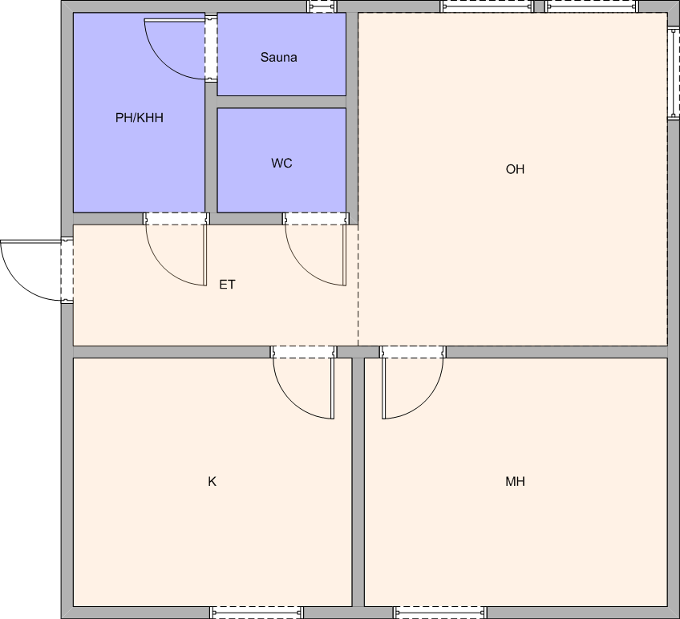
Figure: A building floor plan (architectural blueprint) as an analogy for the symbolic component, guiding construction. Neuro-symbolic AI uses such “blueprints” (logical rules, ontologies) with the flexibility of neural learning. In medicine, for instance, an AI might use neural vision to parse an X-ray and symbolic logic to apply diagnostic rules.
Neuro-symbolic systems span a spectrum (Kautz’s taxonomy). For example:
- Type 1 (Symbolic Neuro-Symbolic): A symbolic model where some rules are implemented by neural networks. E.g. an expert system whose inference engine calls a neural oracle for certain sub-tasks.
- Type 2 (Symbolic[Neural]): Symbolic knowledge guides the training of neural networks. E.g. training a neural model with constraints from a knowledge graph.
- Type 3 (Neural | Symbolic): Neural and symbolic modules run in parallel, cooperating. E.g. a perception network feeds a symbolic planner, both working on the same problem.
- Type 4 (Neuro: Symbolic→Neuro): A system that compiles symbolic rules into a neural network. E.g. encoding logic formulas as weights or a network architecture.
- Type 5 (Neuro₍symbolic₎): Neural networks with symbolic structures baked in (like Neural Turing Machines, or memory networks indexed by logic).
- Type 6 (Neuro[Symbolic]): Neural networks that internally perform symbolic reasoning (like a differentiable theorem prover).
Each style has trade-offs. For instance, DeepProbLog (Type 3) extends neural nets with probabilistic logic to answer VQA tasks[19]; Logic Tensor Networks (Type 5) embed logical constraints into the loss function of a neural net; NeurASP (Type 2) uses answer-set programming to guide neural training; Neural Theorem Provers (Type 6) implement backward-chaining in a neural framework. The choice depends on task: visual question answering (CLEVR dataset) benefits from Type 3 systems that parse an image with CNNs and reason over scene graphs[19], while formal reasoning tasks might use Type 1 or 6 approaches.
Why does neuro-symbolic AI matter? Pure neural methods fail at several key problems: they struggle with compositionality (generalising to novel combinations), systematic multi-step reasoning, explainability, and robustness to distribution shifts (like adversarial examples)[19]. For example, a neural language model can generate plausible answers but often gets logical entailment wrong in multi-hop QA, or fails to apply common sense rules reliably. On the other hand, pure symbolic AI fails at perception, natural language understanding, and learning from unstructured data. It can’t easily deal with noisy real-world input or scale to high-dimensional data.
Neuro-symbolic integration addresses these: the neural part handles perception and noisy data, while the symbolic part imposes structure and logic. In effect, it tackles all 10 major shortcomings of isolated paradigms: neural nets gain data efficiency and verifiable logic, symbolic systems gain learning and flexibility.
Ten use cases illustrate this synergy (each with failure modes of pure approaches and the neuro-symbolic fix):
- Visual Question Answering (VQA): Pure neural fails: CNN+LSTM often hallucinate or miscount objects on CLEVR; pure symbolic fails: needs raw vision input. Neuro-symbolic solves: systems like NS-VQA parse an image into objects (neural) and use a symbolic program executor (logic) to answer questions[19]. Real example: NeuroLog (Yin et al.) answered complex queries on synthetic scenes. Without neuro-symbolic, models give gibberish or wrong counts; with it, they provide correct answers with explicit reasoning steps.
- Drug discovery: Pure neural fails: proposing molecules purely by generative models often violates chemistry rules or lacks explainable rationale. Pure symbolic fails: brute-forcing molecules is impossible at scale. Neuro-symbolic solves: combine neural search with symbolic constraints (valence, substructure rules) to propose valid compounds. E.g. ChemTS uses SMILES sequences with constraint checks. Impact: valid leads discovered faster.
- Autonomous driving: Pure neural fails: vision-only models misinterpret rare road situations (e.g. unusual obstacle), pure symbolic fails: cannot recognize raw images. Neuro-symbolic solves: neural perception (cameras, LIDAR) produces symbolic facts (“pedestrian at X,Y”), then a symbolic planner or temporal-logic verifier checks safety (“never run red light”). Systems like DARPA’s Urban Challenge team often combined vision DNNs with formal planners. Without it, cars make dangerous errors or fail to generalise to novel intersections.
- Clinical decision support: Pure neural fails: NLP-based diagnosis can hallucinate conditions without evidence; pure symbolic fails: old rule-based expert systems break when patient data is messy. Neuro-symbolic solves: NLP extracts symptoms and history (neural), which feed into an ontology-based reasoner (symbolic rules) to suggest diagnoses. For example, IBM’s med-certified Watson attempted this, and recent research combines BERT with SNOMED CT rules. This yields interpretable diagnoses with evidence, improving trust. Without NS, chatbots give random advice; with NS, recommendations follow medical logic.
- Fraud detection: Pure neural fails: deep fraud models miss tiny rule-violating patterns or cannot explain alerts; pure symbolic fails: manual rules catch only known schemes. Neuro-symbolic solves: a neural anomaly detector flags unusual transactions, then a rule-based system checks them against regulatory compliance rules. Real systems in banks use this hybrid: a CNN-like model spots potential fraud, then a symbolic rule engine verifies legal compliance. This hybrid finds subtle fraud while giving clear audit trails.
- Robot task planning: Pure neural fails: end-to-end RL may fail on tasks needing multi-step plans; pure symbolic fails: cannot perceive real objects. Neuro-symbolic solves: vision DNN identifies objects and states, PDDL or STRIPS planner computes a plan. For instance, a robot assistant might use vision to locate tools and a symbolic planner to sequence actions (fetch hammer, then nail). Systems like Intel’s RoboBrain or OpenAI’s Solvers combine CNNs with planners. Without NS, robots flail; with NS, they execute complex tasks reliably.
- Scientific discovery: Pure neural fails: language models retrieve patterns from literature but can hallucinate fake references; pure symbolic fails: logic alone cannot read raw text. Neuro-symbolic solves: neural NLP extracts structured hypotheses from papers, symbolic reasoners combine them into new hypotheses. Projects like INDIGO and SciencePIO use knowledge graphs plus ML to generate testable hypotheses. This accelerates research by ensuring new theories are logically consistent with known science. Without NS, AI “discoveries” are often spurious; with NS, they are plausible and verifiable.
- Legal document analysis: Pure neural fails: LLM contracts summarisation misses nuanced clauses; pure symbolic fails: cannot interpret natural language legal text. Neuro-symbolic solves: NLP parses contracts into structured facts, a symbolic engine applies legal rules. For example, a system might flag “missing indemnification clause” by extracting entities and checking rule compliance. Legal tech firms (ROSS Intelligence, etc.) are exploring this. Without NS, violations slip through; with NS, contracts are thoroughly checked.
- Manufacturing quality control: Pure neural fails: vision models catch defects but cannot enforce engineering constraints; pure symbolic fails: manual rules cannot inspect raw images. Neuro-symbolic solves: a vision net finds anomalies (crack, scratch), a physics-based symbolic model checks if they violate tolerance rules. For instance, Microsoft’s NExT uses hybrid vision+physical simulators for hardware QC. This ensures only truly faulty parts are flagged. Without NS, false positives/negatives proliferate; with NS, only real defects are reported.
- Conversational AI with grounding: Pure neural fails: chatbots confidently lie (hallucinate facts); pure symbolic fails: can’t hold open dialogue. Neuro-symbolic solves: an LLM generates a preliminary answer, then queries a knowledge graph or logic reasoner to verify factual claims. Efforts like combining GPT-4 with Wolfram Alpha or a formal KB serve this goal. A neuro-symbolic chatbot might say “According to verified sources, X=5” rather than inventing. This approach ensures consistency and trust. Without NS, AI can misinform at scale.
If we don’t integrate neuro-symbolic ideas, we risk serious failures. For example, LLMs in medicine have already given unsafe advice because they hallucinate (pure neural). Self-driving cars purely learned (e.g. Tesla’s initial vision-only) struggle with rare edge cases. Early expert systems (pure symbolic) crumbled outside their narrow domains and were brittle to noise. Chatbots often contradict themselves within a conversation (lack of symbolic consistency). In each scenario above, a neuro-symbolic approach would have provided a safety net: e.g. an AI doctor that must back up diagnoses with ontology-based checks, or a driving agent that must verify any neural plan against formal safety rules.
Benefits of neuro-symbolic approaches are now being documented. They tend to be far more data-efficient (needing far less training data) because the symbolic structure provides inductive bias; some studies report 10–100× less data needed for similar performance. They are more explainable: the symbolic part can output a reasoning chain or rule matches. They are more robust: logical constraints (e.g. type checks, invariants) prevent entire classes of errors (like a medical robot never violating X-ray exposure limits). They support compositional generalisation: because concepts are encoded symbolically, the system can handle novel combinations of known concepts. Importantly, they instill trust and verifiability: a neuro-symbolic system can be partially verified (e.g. the logical component can be proven to enforce certain safety invariants). Benchmarks on tasks like CLEVR or CLUTRR show neuro-symbolic models far outperform pure neural nets on generalisation and correctness.
Existing frameworks exemplify these ideas. DeepProbLog (Type 3) extends Prolog with neural predicates; it can answer visual questions by combining CNN perception with logical inference. Logic Tensor Networks (LTN) embed logic constraints into the loss of a neural net, allowing it to learn with symbolic supervision. Neural Theorem Provers (Type 6) train vector embeddings of symbols and then learn to prove new queries by neural attention. AlphaProof / OpenAI’s neural theorem provers integrate neural tactic suggestion with a formal proof assistant (the intern+auditor model). LNN (Logical Neural Networks) at IBM implements Boolean logic operations as neural layers. Each tool shows that neuro-symbolic methods can improve accuracy or data efficiency by orders of magnitude over baselines on complex tasks.
In short, neuro-symbolic AI is not a single technique but a spectrum: from softly guided neural networks (incorporating logic penalties) to hard symbolic compilers (neural nets that exactly implement logic). The unifying principle is that neural and symbolic strengths compensate each other: perception and learning from neural nets, plus reasoning and guarantees from symbolic logic. This hybridisation is seen by many as the path to truly trustworthy, general AI.
Citations: Definition and context from Kautz et al.[19], examples (DeepProbLog etc)[19], neuro vs pure failures[19], medical ontology[12], AWS compliance (reflecting rule-checks)[14], LNN and others from surveys.

[1] Automated Reasoning (Stanford Encyclopedia of Philosophy)
https://plato.stanford.edu/entries/reasoning-automated/
[2] [19] Soundness - Wikipedia
https://en.wikipedia.org/wiki/Soundness
[3] Abductive reasoning - Wikipedia
https://en.wikipedia.org/wiki/Abductive_reasoning
[4] [5] Easy Problems That LLMs Get Wrong
https://arxiv.org/html/2405.19616v2
[6] Ariane flight V88 - Wikipedia
https://en.wikipedia.org/wiki/Ariane_flight_V88
[7] 30-year-old Pentium FDIV bug tracked down in the silicon — Ken Shirriff takes the microscope to Intel's first-ever recall | Tom's Hardware
https://www.tomshardware.com/pc-components/cpus/30-year-old-pentium-fdiv-bug-tracked-down-in-the-silicon-ken-shirriff-takes-the-microscope-to-intels-first-ever-recall
[8] Software Testing Lessons Learned From Knight Capital Fiasco | CIO
https://www.cio.com/article/286790/software-testing-lessons-learned-from-knight-capital-fiasco.html
[9] It’s Time to Start Using Formal Methods for Engineering Embedded Systems - QRA
https://qracorp.com/whitepapers/its-time-to-start-using-formal-methods-for-engineering-embedded-systems/
[10] Galois - Proving Amazon’s s2n correct
https://www.galois.com/project/amazon-s2n
[11] How AWS uses automated reasoning to help you achieve security at scale | AWS Security Blog
https://aws.amazon.com/blogs/security/protect-sensitive-data-in-the-cloud-with-automated-reasoning-zelkova/
[12] Using clinical reasoning ontologies to make smarter clinical decision support systems: a systematic review and data synthesis - PMC
https://pmc.ncbi.nlm.nih.gov/articles/PMC6913230/
[13] [PDF] Formal verification of a realistic compiler - Xavier Leroy
https://xavierleroy.org/publi/compcert-CACM.pdf
[14] Build verifiable explainability into financial services workflows with Automated Reasoning checks for Amazon Bedrock Guardrails | Artificial Intelligence
https://aws.amazon.com/blogs/machine-learning/build-verifiable-explainability-into-financial-services-workflows-with-automated-reasoning-checks-for-amazon-bedrock-guardrails/
[15] [1702.01135] Reluplex: An Efficient SMT Solver for Verifying Deep Neural Networks
https://arxiv.org/abs/1702.01135
[16] How Amazon Web Services uses formal methods - Amazon Science
https://www.amazon.science/publications/how-amazon-web-services-uses-formal-methods
[17] 1025469.pdf
https://ntrs.nasa.gov/api/citations/20100036670/downloads/20100036670.pdf
[18] Deductive reasoning - Wikipedia
https://en.wikipedia.org/wiki/Deductive_reasoning

